***RDBMS AND SQL Assignments Name : Ch.Vinay Kiran***

***Assignment 1: Analyze a given business scenario and create an ER diagram that includes entities, relationships, attributes, and cardinality. Ensure that the diagram reflects proper normalization up to the third normal form.***

*ER-Model****:*** *A model for identifying entities to be represented in a database and displaying the relationships between those entities is called the Entity Relational Model. The enterprise schema specified by the ER data model represents a database's overall logical structure.*

*The relationships between the entities found in the database are explained by the entity relationship diagram. Real-world things such as people, cars, and companies, as well as the relationships between them, are modeled using ER models. The database's structural format is, in essence, represented by the ER Diagram.*

*Entities: An Entity may be an object with a physical existence a particular person, car, house, or employee or it may be an object with a conceptual existence a company, a job, or a university course.*

*Attributes****:*** *Attributes are the properties that define the entity type. For example, Roll_No, Name, DOB, Age, Address, and Mobile_No are the attributes that define entity type Student. In ER diagram, the attribute is represented by an oval.*

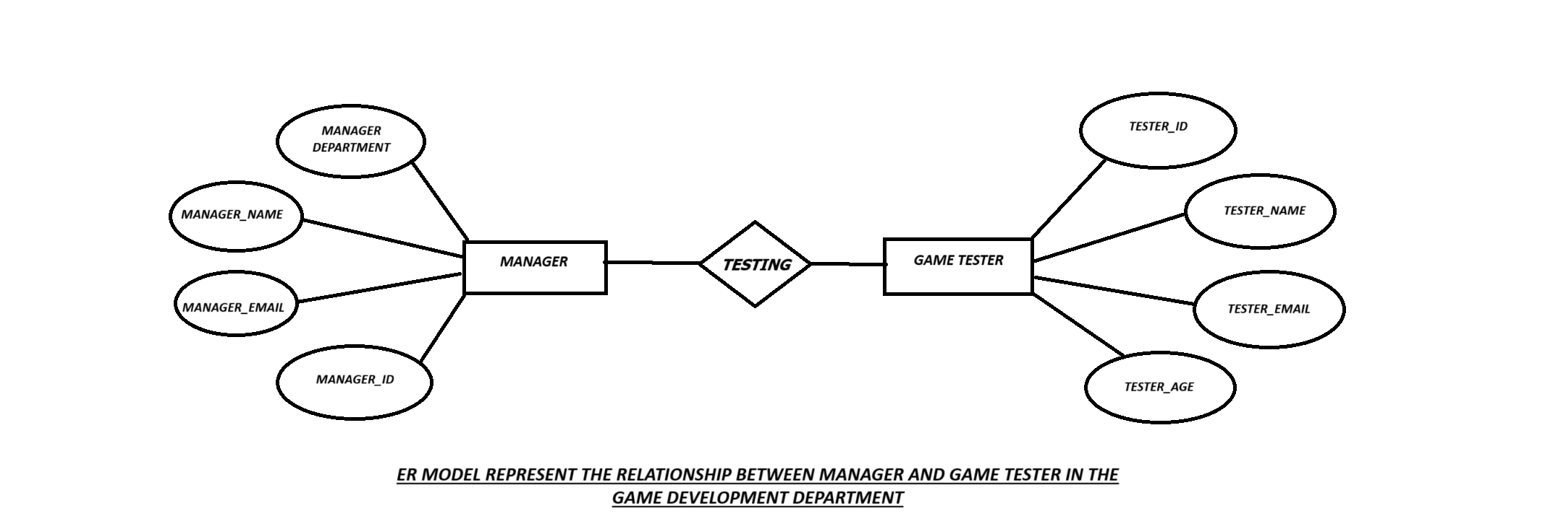

*Normalization:Database Management Systems (DBMS) use a method called normalization to assist organize data in databases in order to reduce redundancy and enhance data integrity. It involves dividing up the data into more manageable chunks and keeping track of each chunk in a different table. By ensuring that each piece of data is kept in a single location, this procedure makes it simpler to maintain and update the data.*

*First Normalization form (1NF): Every attribute is indivisible and atomic.*

*No groups of values or repetitive groupings.Because there are no recurring groups and just atomic values in each attribute, the ER model is already in 1NF.*

*Second Normalization form (2NF): The entity is in 1NF. And all non-key attributes are fully functional dependent on the primary key. The ER model is already in 2NF because each non-key attribute is fully functionally dependent on the primary key.*

*Third Normalization Form (3NF): The entity is in 2NF.There are no transitive dependencies in the ER model.As the ER model is already in 3NF because there are no transitive dependencies. All non-key attributes are directly dependent on the primary key, and there are no non-key dependencies between the attributes.*

***Assignment 2: Design a database schema for a library system, including tables, fields, and constraints like NOT NULL, UNIQUE, and CHECK. Include primary and foreign keys to establish relationships between tables****.*

*The database schema for a library system, including tables, fields, and constraints like NOT NULL, UNIQUE, and CHECK. Including the primary key and the foreign key established for the library database.*

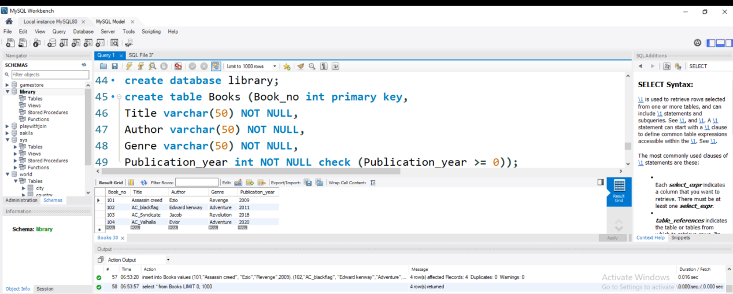

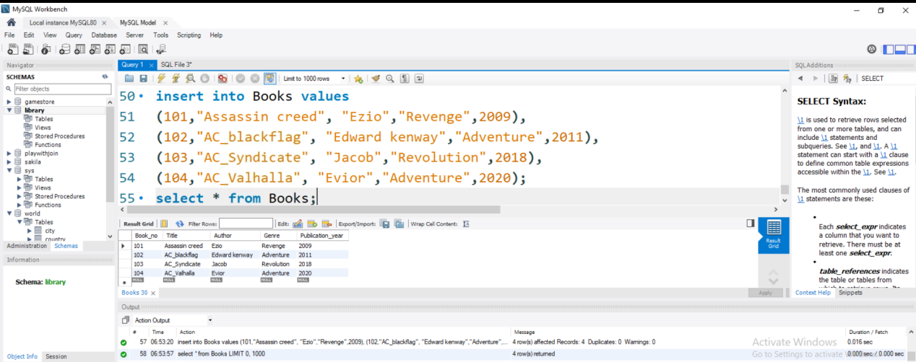

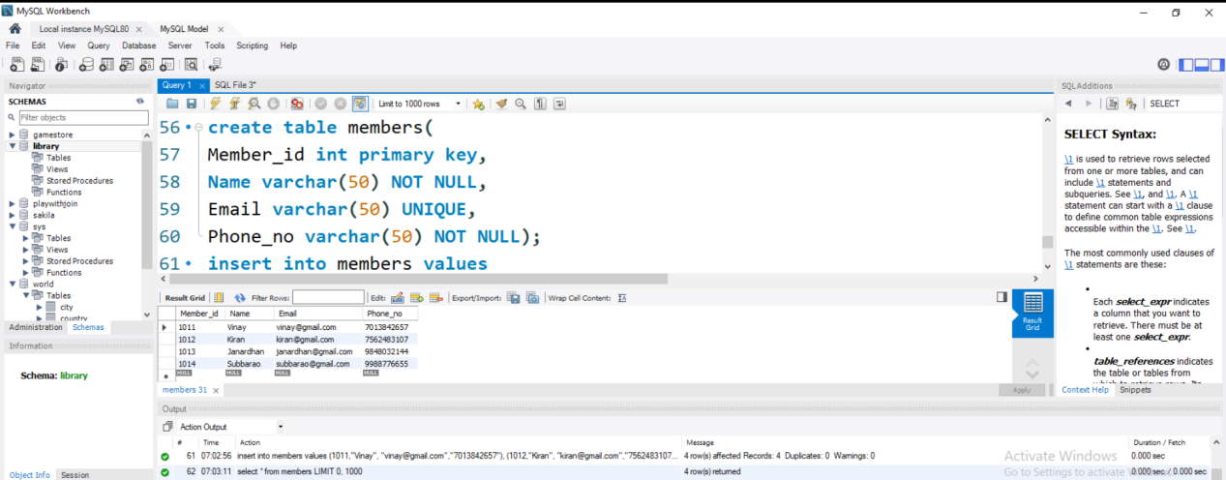

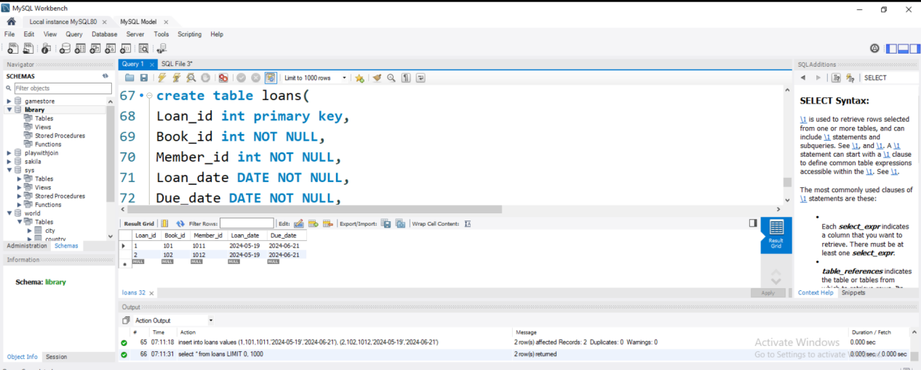

*Assignment 3: Explain the ACID properties of a transaction in your own words. Write SQL statements to simulate a transaction that includes locking and demonstrate different isolation levels to show concurrency control.*

*The ACID Properties of a transaction: The ACID properties of a transaction in a Database Management System (DBMS) are the main four operations that ensures the reliability and consistency of a transaction. The acronym of ACID stands for Atomicity, Consistency, Isolation, and Durability.*

*Atomicity: This guarantees that a transaction is handled as a single, indivisible work unit. The transaction is rolled back in its entirety and the database is restored to its initial state if any portion of it fails. This feature makes sure that, even in the case of an error or failure, the database stays consistent.*

*Consistency: By establishing that a transaction follows by the guidelines and limitations established for the database, consistency ensures that a transaction preserves the integrity of the database. This attribute makes sure that even after the transaction has been completed, the database stays consistent.   
Isolation: Isolation guarantees that every transaction runs separately from the others and that a transaction's effects are hidden from other transactions until it is committed. This feature makes sure that different transactions can run simultaneously without affecting one another.*

*Durability: Durability makes sure that once a transaction is completed, its consequences are irreversible and cannot be undone. This feature makes sure that even in the case of a system crash or failure, the database stays in a consistent state.   
In conclusion, even in the case of faults or failures, the ACID features of a transaction in a DBMS guarantee that the database maintains a consistent and dependable state. The correctness and integrity of the data kept in the database depend on these attributes.*

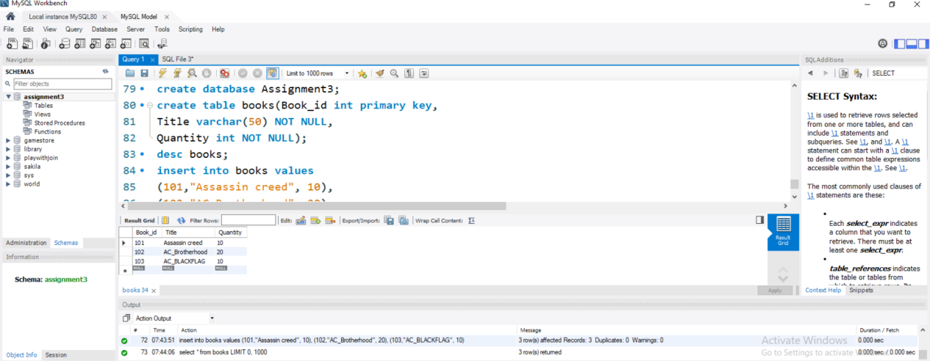

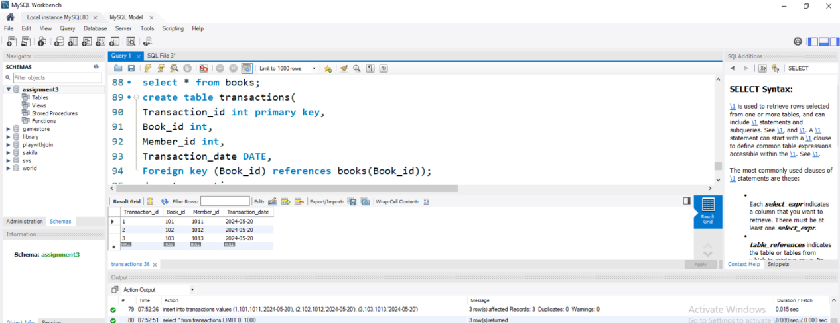

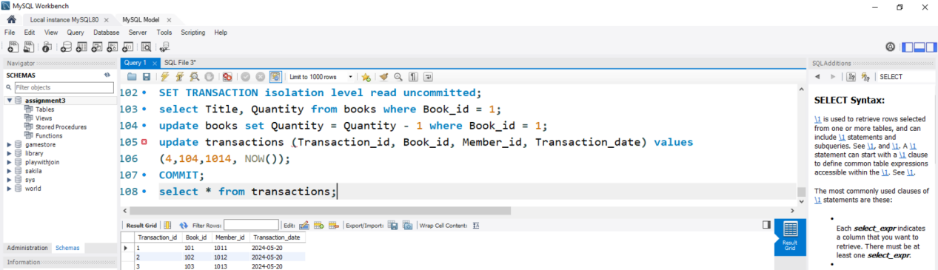

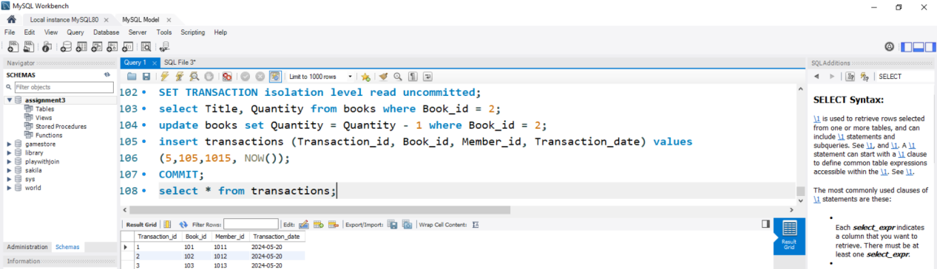

*So, by the isolation principle the database query are independent to one another. By the isolation level is read committed, it only reads committed data. Therefore, it won’t read uncommitted changes from other transactions.*

*Assignment 4: Write SQL statements to CREATE a new database and tables that reflect the library schema you designed earlier. Use ALTER statements to modify the table structures and DROP statements to remove a redundant table.*

*The SQL statements to create a new database and tables that reflect the library schema:*

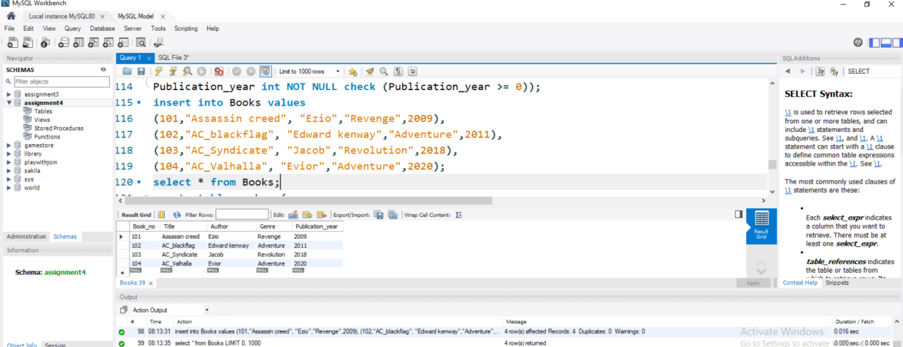

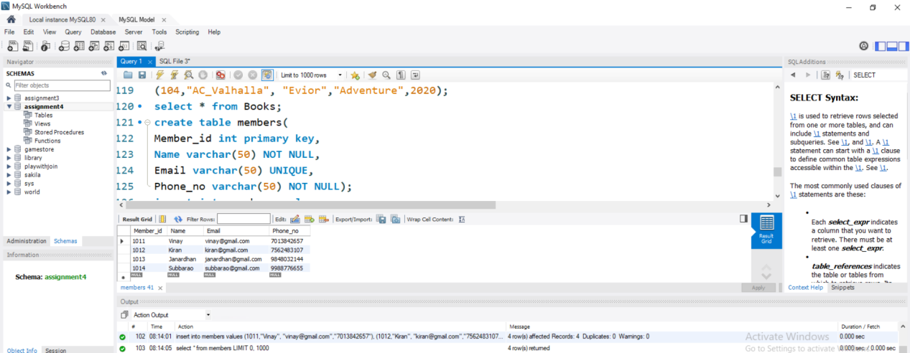

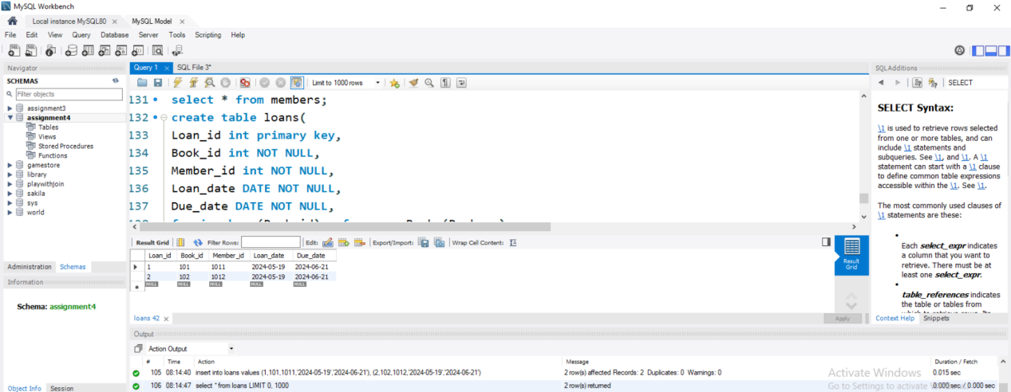

*NOW IN THE LIBRARY SCHEMA TO ALTER THE DATA IN DATABASE WE USE ALTER STATEMENT .*

*In the above database for table Book we are adding location column to it.*

*And drop statement in the sql is used to delete the table or the selected fields.*

*In the above database we are removing the loans table.*

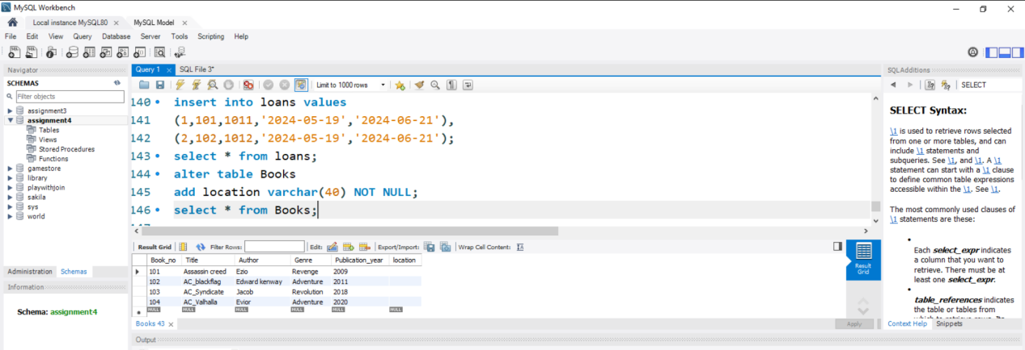

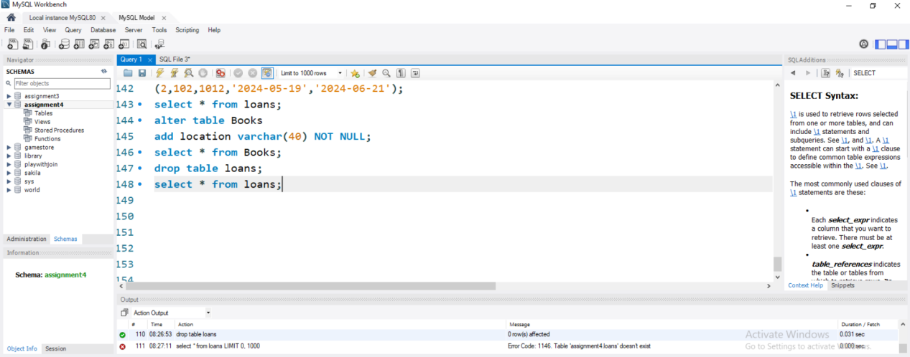

*Assignment 5: Demonstrate the creation of an index on a table and discuss how it improves query performance. Use a DROP INDEX statement to remove the index and analyze the impact on query execution.*

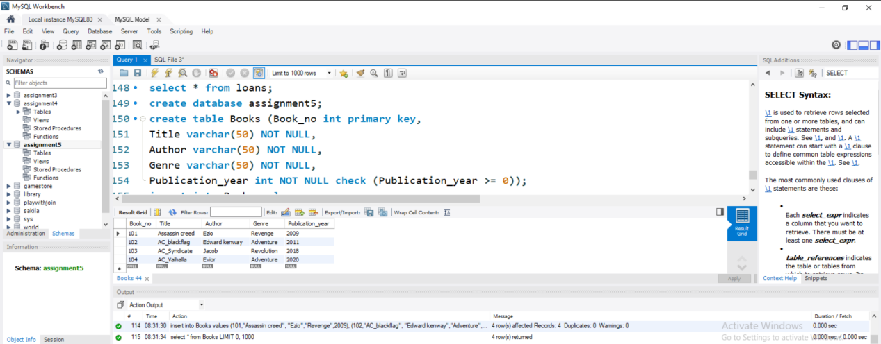

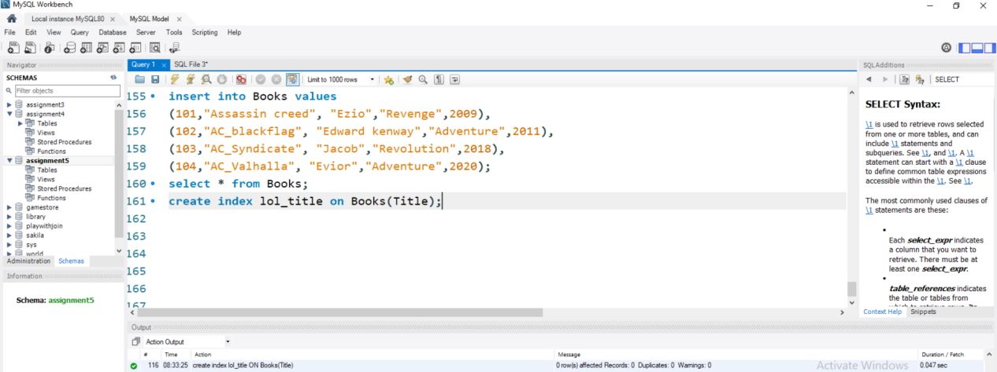

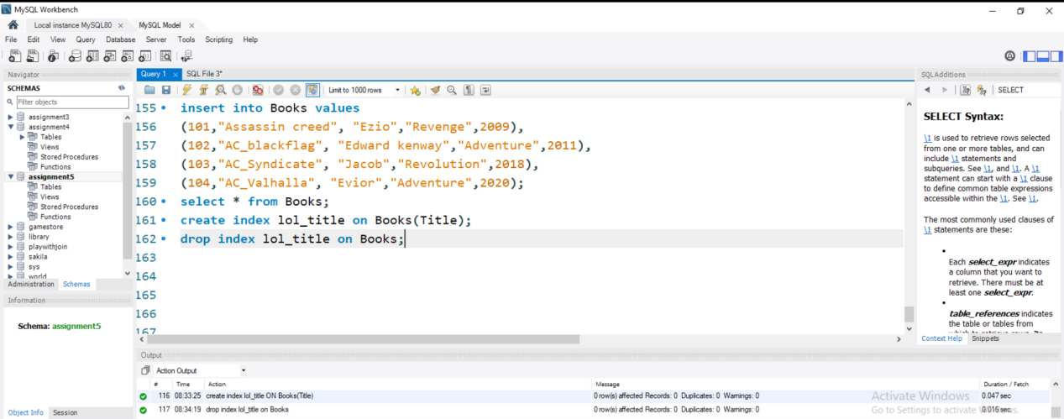

*By the help of index we can access the data present in the database faster, As when we execute a query that involve the index variable, the database engine can use the index to quickly search the relevant rows instead of scanning the entire table.*

*Indexes stores a copy of sorted indexed column’s, which allows the database engine to perform more efficiently.*

*And without indexes the database engine need to search the whole database to read or to perform an action of the data present in the database. Which will lead to slower query execution, especially for large tables with many rows.*

*Assignment 6: Create a new database user with specific privileges using the CREATE USER and GRANT commands. Then, write a script to REVOKE certain privileges and DROP the user.*

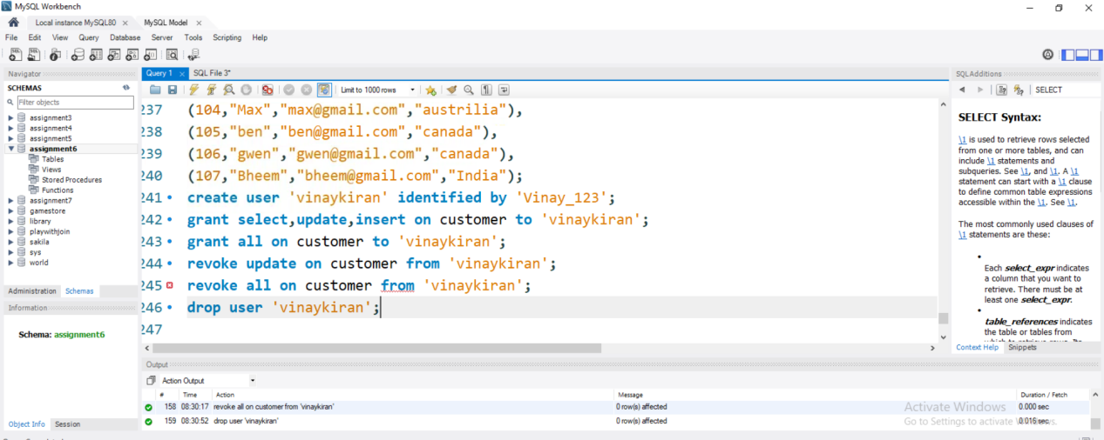

*Assignment 7: Prepare a series of SQL statements to INSERT new records into the library tables, UPDATE existing records with new information, and DELETE records based on specific criteria. Include BULK INSERT operations to load data from an external source.*

*INSERTING NEW RECORDS INTO LIBRARY TABLES.*

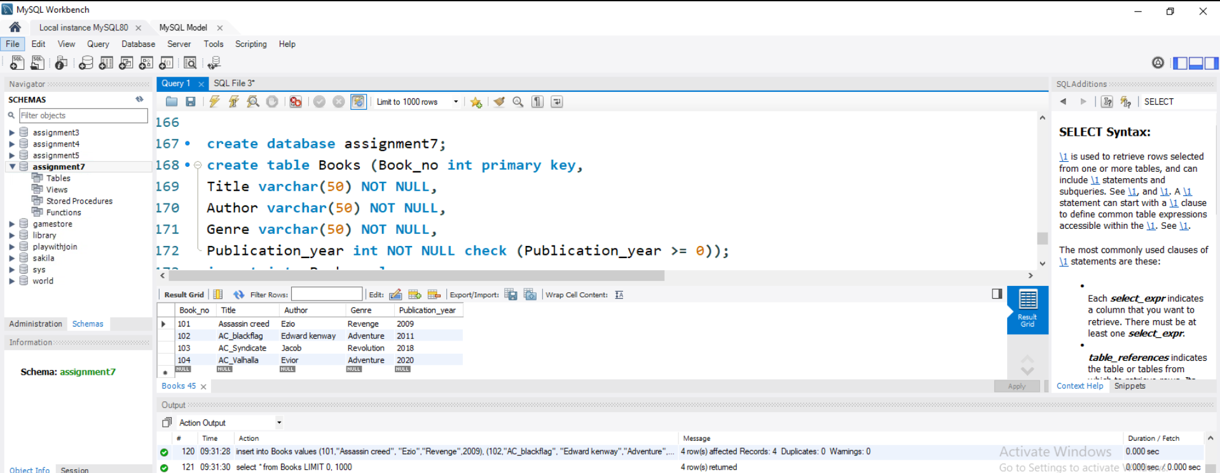

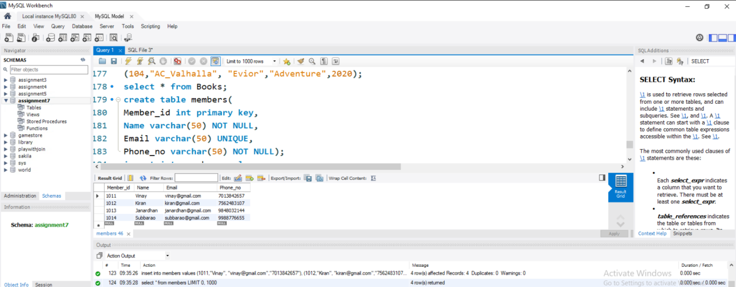

*UPDATE existing records with new information*

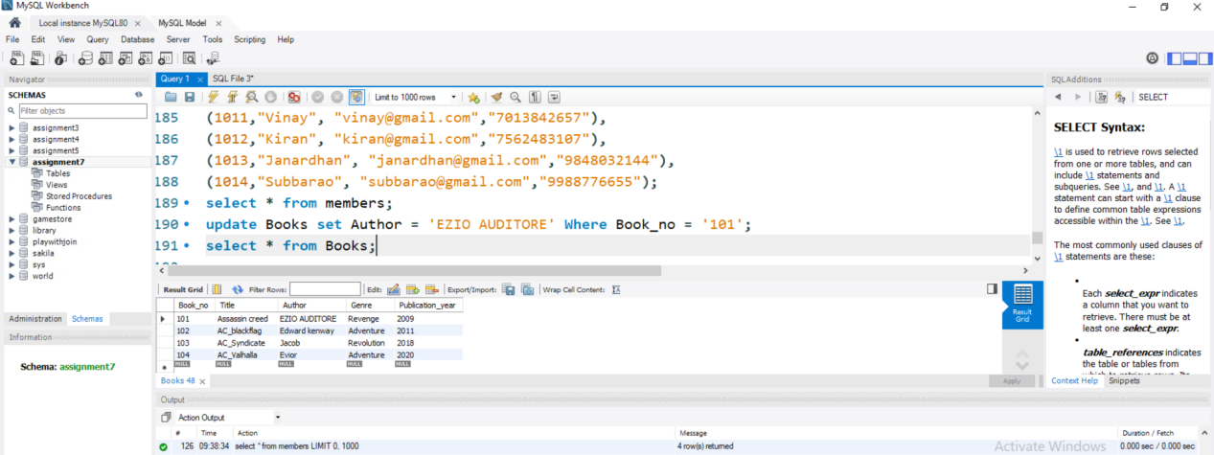

*DELETE records based on specific criteria*

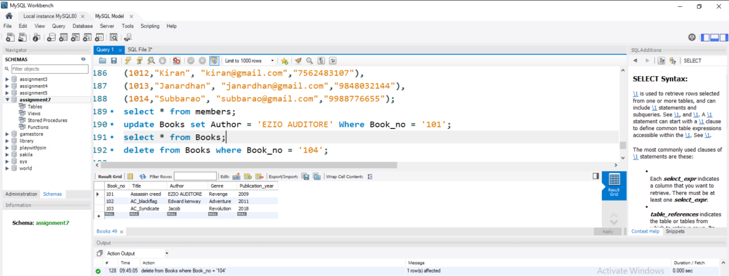

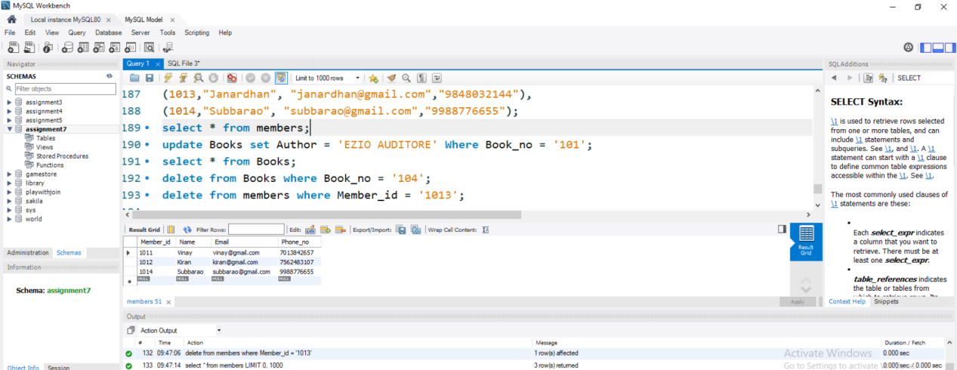

*Bulking inserting the data into the database:*

**

*====================================================================*

*Day-2: Assignment 1: Name : Ch.Vinay Kiran*

*Write a SELECT query to retrieve all columns from a 'customers' table, and modify it to return only the customer name and email address for customers in a specific city.*

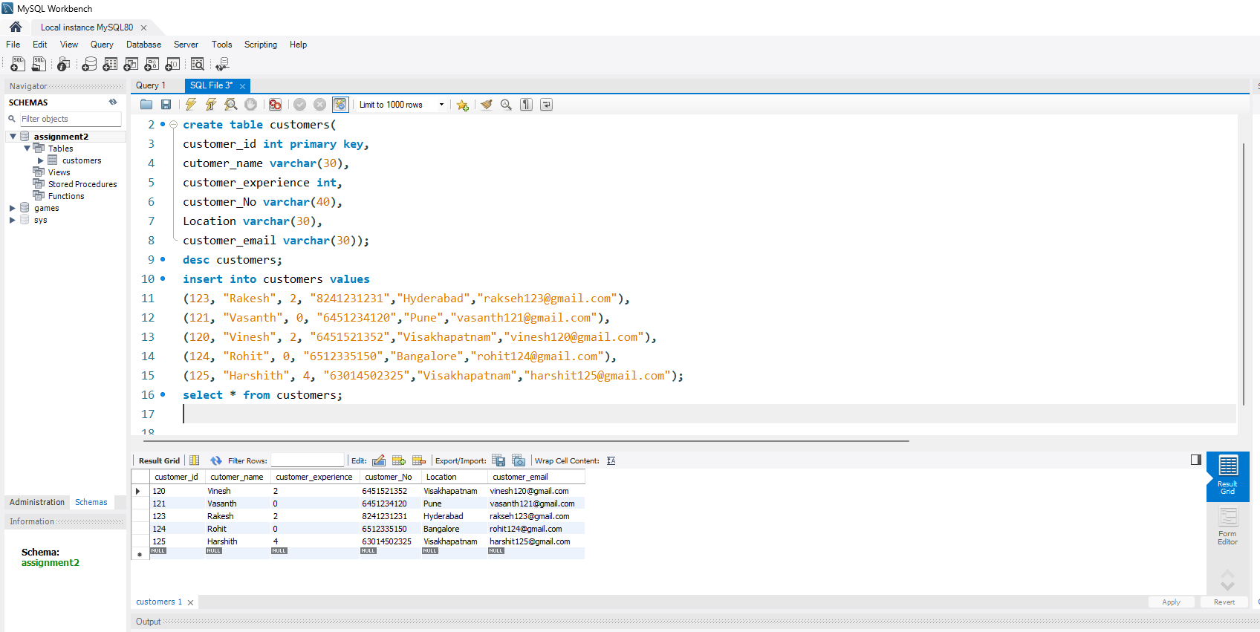

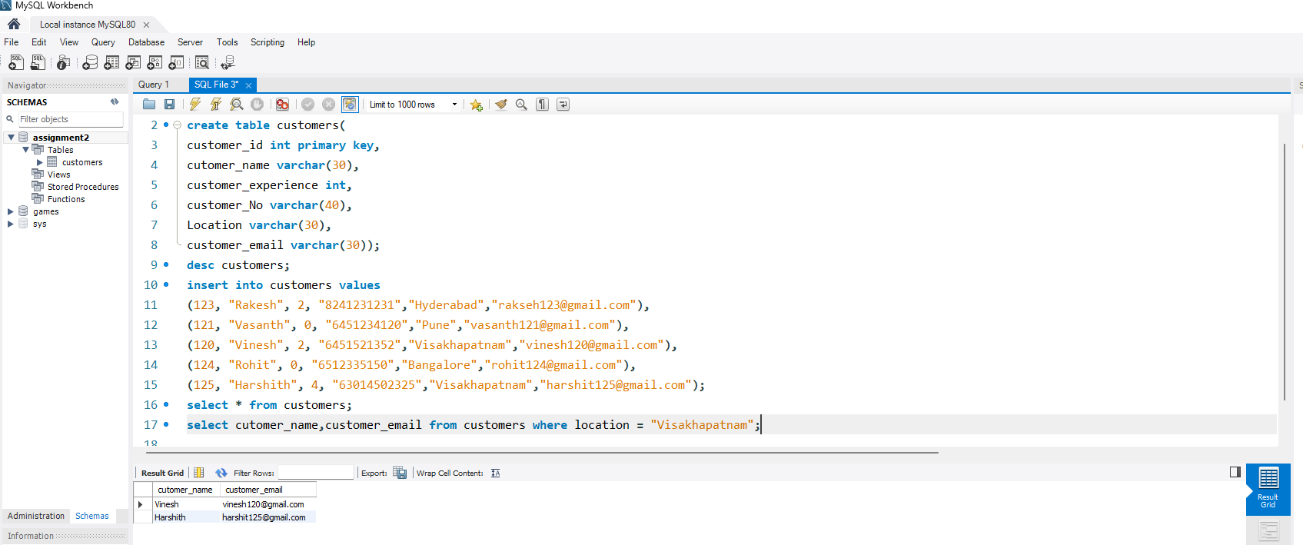

*Assignment-2: Craft a query using an INNER JOIN to combine 'orders' and 'customers' tables for customers in a specified region, and a LEFT JOIN to display all customers including those without orders.*

**

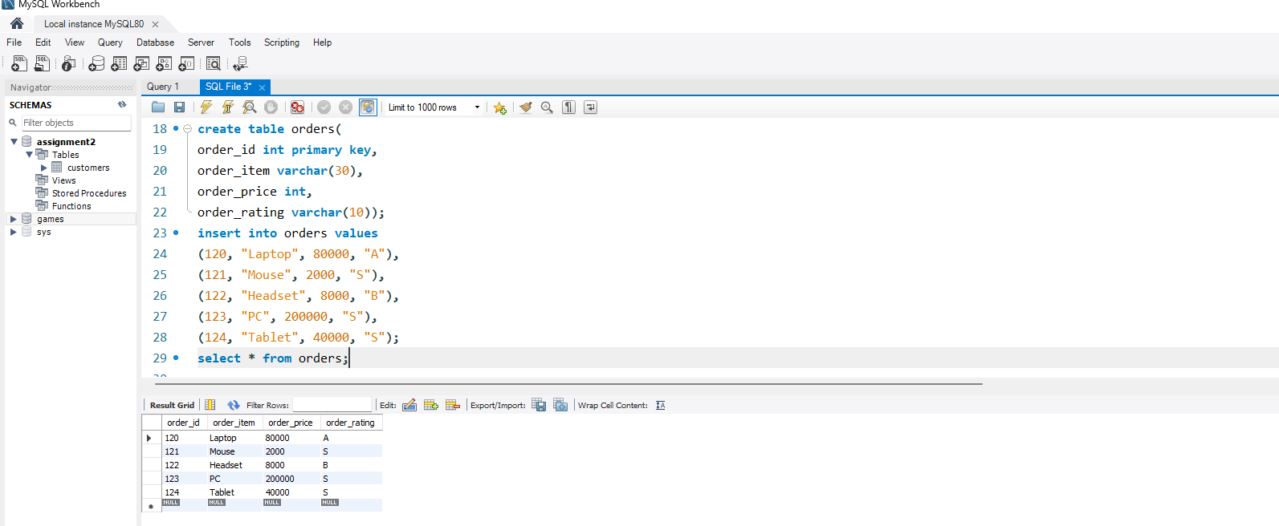

*Performing the Inner Join the tables customer and the order table.*

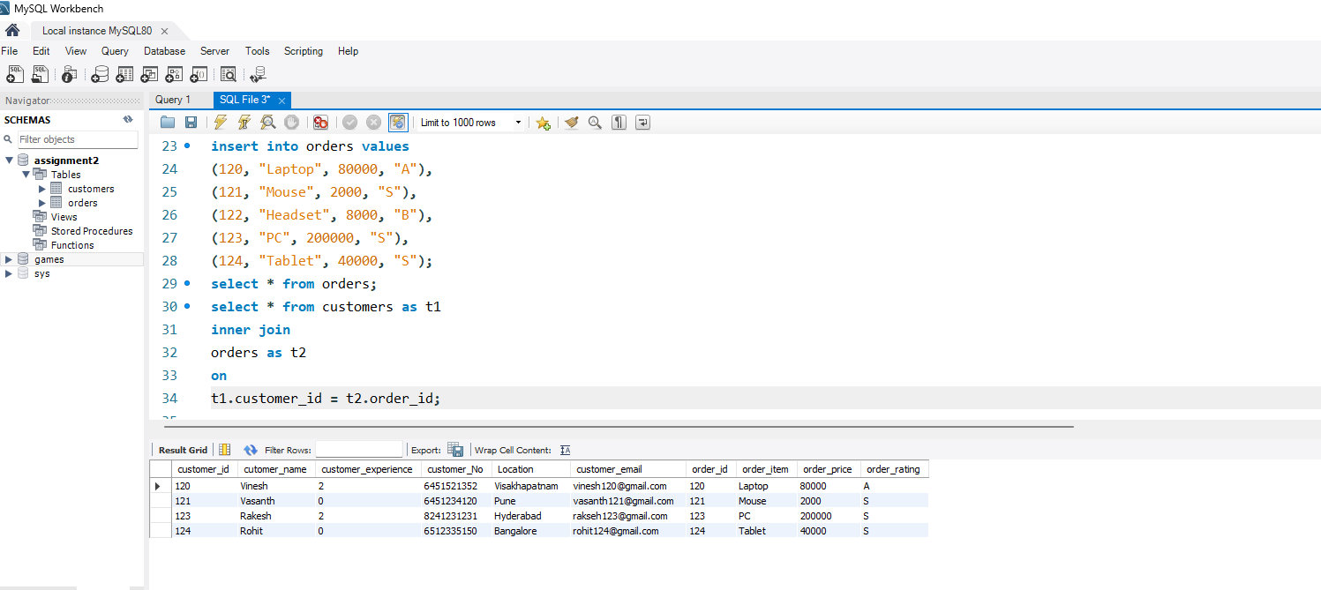

*Now Performing the inner join to the customer and order tables based on the region.*

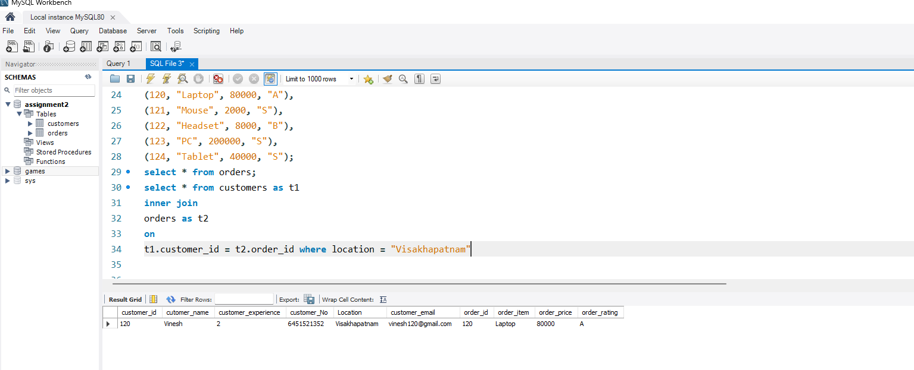

*Performing the Left Join on the tables customer and orders and displaying all the customers including the customers without orders.*

**

**

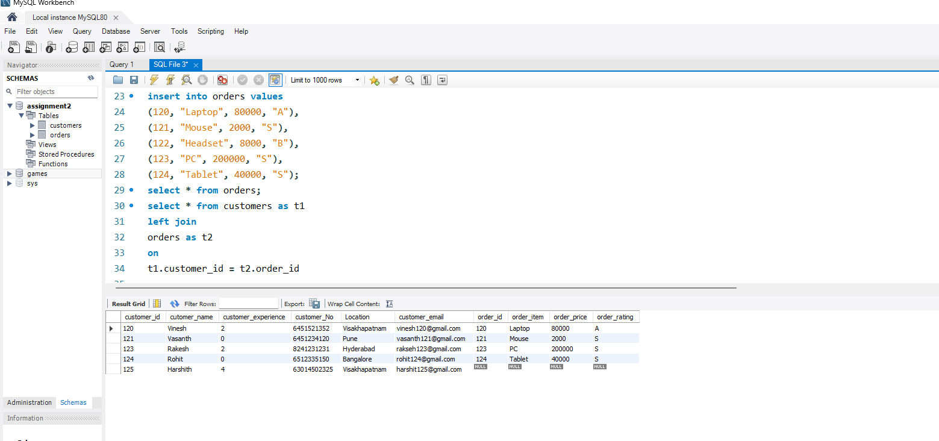

*Assignment 3: Utilize a sub-query to find customers who have placed orders above the average order value, and write a UNION query to combine two SELECT statements with the same number of columns.*

**

**

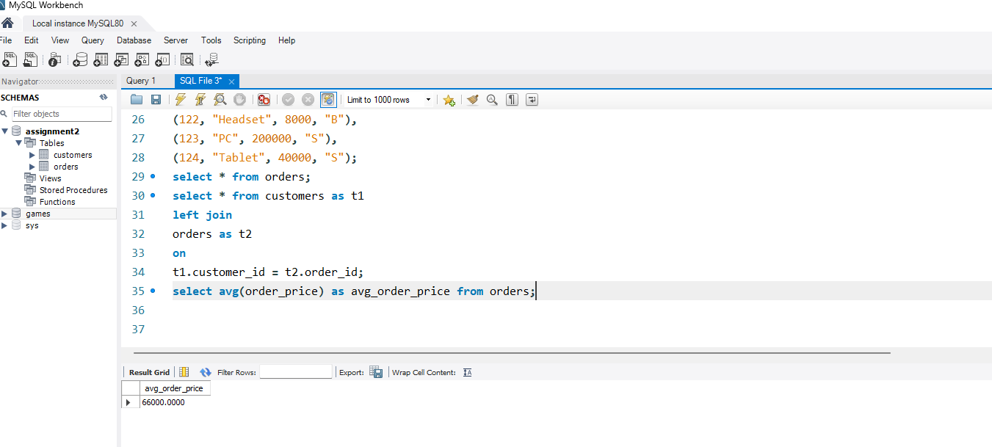

*The customers who have placed orders above the average order value*

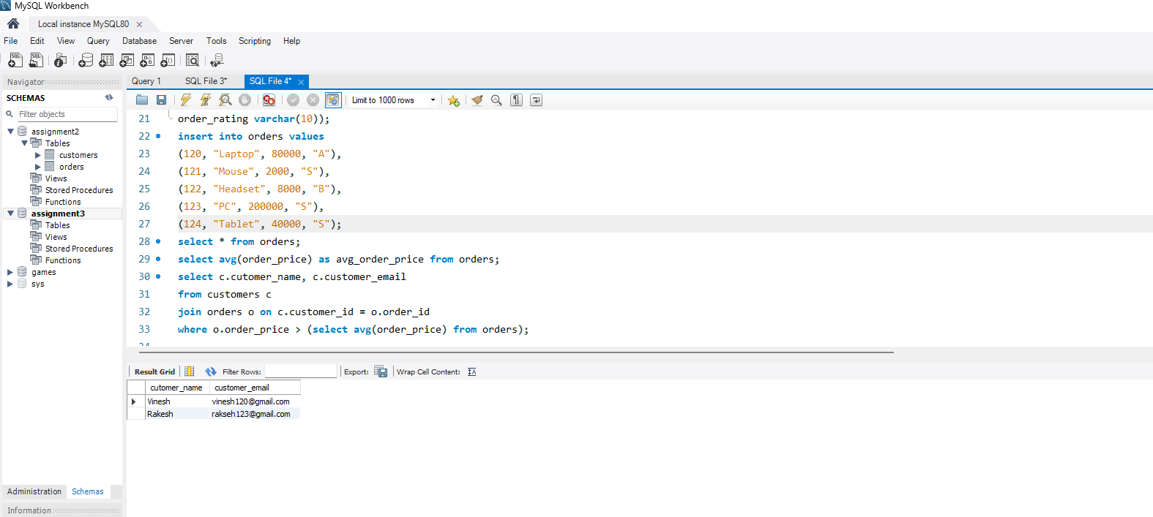

*UNION query to combine two SELECT statements with the same number of columns.*

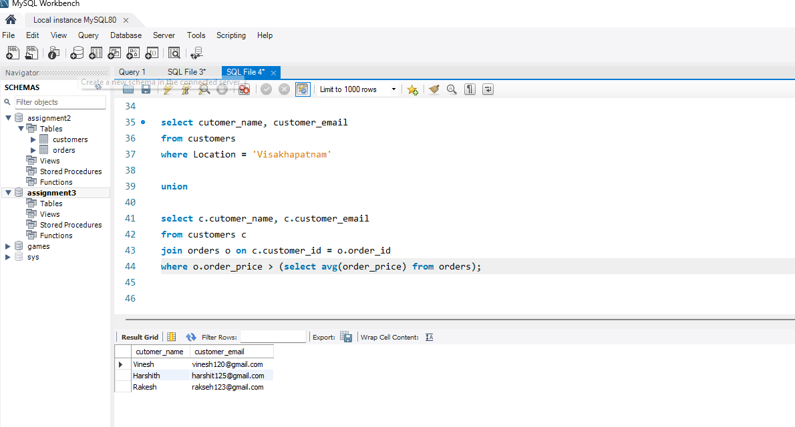

*Assignment 4: Compose SQL statements to BEGIN a transaction, INSERT a new record into the 'orders' table, COMMIT the transaction, then UPDATE the 'products' table, and ROLLBACK the transaction.*

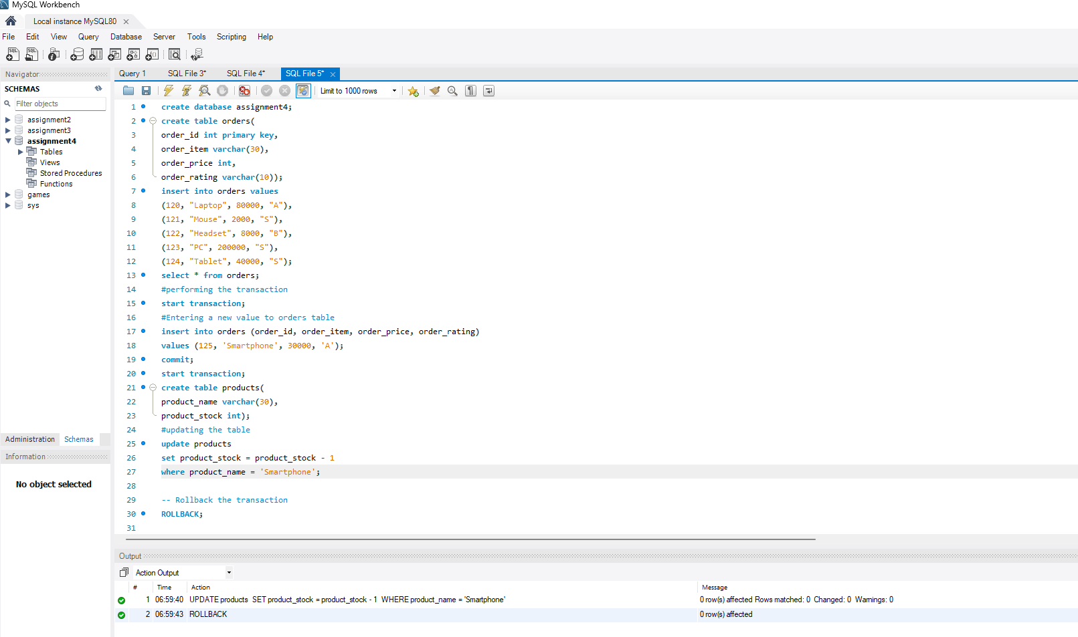

*Assignment 5: Begin a transaction, perform a series of Inserts into 'orders', setting a SAVEPOINT after each, rollback to the second SAVEPOINT, and COMMIT the overall transaction.*

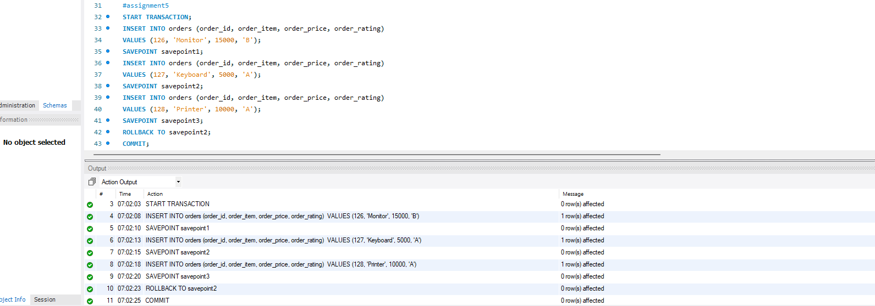

*Assignment 6: Draft a brief report on the use of transaction logs for data recovery and create a hypothetical scenario where a transaction log is instrumental in data recovery after an unexpected shutdown.*

*A brief report on the use of transaction logs for data recovery.*

*Transaction logs are essential for maintaining data integrity and supporting database recovery methods. They serve as an in-depth record of all database modifications, delivering a means of restoring data to a consistent state in the event of malfunctions like unplanned system shutdowns, corruption, or data loss.*

*The Importance of the transaction log’s in data recovery:*

*Every transaction that modifies the database is recorded in the transaction logs. Insertions, updates, removals, and schema revisions fall under this category. Every log entry captures the specifics of the transaction, such as:*

* *Time and Date*
* *Transaction ID*
* *Type of the operation*
* *Prior to and post the changed values*

*The transaction log’s are updated at frequent time intervals, which helps the data to be secure and ensure data integrity.*

*And By the help of the transaction log’s the human errors caused to the database can be rollback as it acts like a break point in every transaction is performed, so in case of human error, we can simply rollback. The Transaction logs enable the restoration of the data to a specific point in time, allowing data recovery from human errors and logical errors.*

*The Transaction logs are used to bring the database back to a consistent state by rollback incomplete transaction and replaying committed ones during the system crash or unexpected system shutdown occurred due to blue-screen-errors, hardware errors, etc.*

*Hypothetical Scenario for the data recovery after an unexpected shutdown:*

*Scenario: A software company’s central database suffers an unexpected shutdown due to an logical error caused by the employee during the office hours. As the employee is a new recruit, by his logical error, he deleted the main frame database which caused the whole database to shutdown. So in this scenario the database administrator needs to recover the database to its normal working state.*

*Steps to data recovery:*

*Initially the DBA needs to find the cause to the unexpected shutdown:*

*The database administrator (DBA) assesses the situation and confirms the cause to the unexpected shutdown which is caused by the employee.*

*The DBA identifies the latest full backup taken at 2:00 PM.*

*The DBA restores the database from the full backup taken at 2:00 PM. At this point, the database reflects its state as of 2:00 PM, missing all transactions from 2:00 PM to 2:55 PM.*

*The DBA access the transaction logs to rollback :*

*The DBA retrieves the transaction logs from 2:00 PM to 2:55 PM. These logs contain all the transactions made during this period.*

*The DBA applies the transaction logs sequentially to the restored database. Each transaction is replayed, ensuring that the database reflects every change made during the logged period.*

*The DBA ensures the logs are applied up to 2:55 PM, the desired recovery point.*

*Once the transaction logs are applied, the DBA verifies the database to ensure all data is consistent and accurate.*

*The DBA checks for any incomplete transactions at 2:55 PM, ensuring they are either completed or rolled back appropriately.*

*Bring the Database Online:*

*The DBA brings the database back online for normal operations.*

*Users can now access the database, which is restored to its state as of 2:55 PM, just before the unexpected shutdown.*

*So In the conclusion, the transaction logs are very vital in restoring the database back to its working state, as it provide a reliable method to restore data accurately and achieve data integrity. As the transaction logs contains all history of all transactions, which ensures that databases can be restored to a consistent and functional state even after unexpected shutdowns and logical errors.*